2024 Garden Waste Collections.
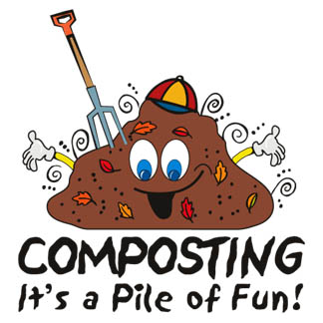
Last Saturday of the month from March to November.
Any changes will be on Cllr Tyrrells Facebook page, please check.

March 30th Long Sutton
April 27th Lutton
May 25th Sutton Bridge
June 29th Tydd
July 27th Long Sutton
August 31st Sutton Bridge
Sept 28th Lutton
October 26th Tydd
November 30th Long Sutton (Weather permitting)

This service is funded by Parish Councils. Cllrs Jack Tyrrell & David Wilkinson, give their time and organise each collection.

